week 3.16 zichao

Core Controller and System Interconnect
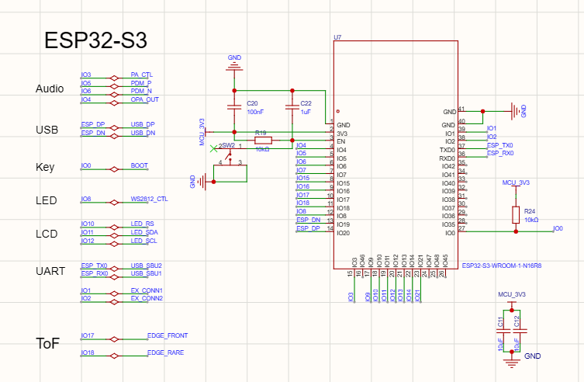
This schematic diagram illustrates the central processing hub of the robot, based on the ESP32-S3-WROOM-1-N16R8 module. It serves as the "brain" of the system, managing all high-level tasks including dual-core processing, Wi-Fi/Bluetooth connectivity, and the orchestration of various subsystems such as Audio, USB communication, LCD interface, and sensor data acquisition.
2. Design Rationale
- Module Selection: The ESP32-S3 variant was chosen specifically for its integrated AI acceleration instructions and its N16R8 configuration (16MB Flash / 8MB PSRAM). This memory overhead is critical for handling the image frame buffers required for the computer vision tasks and the complex data structures involved in the Cloud AI interaction.
- Power Stability & Decoupling: Multiple decoupling capacitors (C20, C22, C11, C12) are placed near the VCC pins. The combination of 100nF (for high-frequency noise) and 1uF/10uF (for bulk energy storage) ensures that the SoC remains stable during transient power spikes caused by Wi-Fi bursts or motor startups.
- Bootstrap & Reset Logic:
  - BOOT (IO0) and EN (Reset) circuits are designed with 10kΩ pull-up resistors (R24, R19) to ensure the chip defaults to the correct execution mode.
  - The manual BOOT button (SW2) allows for easy entry into firmware download mode, facilitating rapid iterative development.
- Peripheral Mapping:
  - USB Native Interface: Utilizes IO19/IO20 for direct USB communication, which simplifies debugging and eliminates the need for an external USB-to-UART chip.
  - Audio PDM: Dedicated pins (IO5, IO6) are assigned for differential PDM output, matching the requirements of the downstream power amplifier (PA) circuit.
  - LCD & LED Control: High-speed SPI pins and dedicated PWM-capable GPIOs (like IO8 for WS2812B) are selected to ensure low-latency visual feedback.
3. Expected Outcome
This configuration provides a robust and scalable foundation for the robot's hardware. By utilizing the native USB and ample PSRAM, the design achieves high-speed data throughput for both programming and real-time sensor processing. The careful management of decoupling and strapping pins minimizes the risk of "brown-out" resets or boot failures, ensuring the system remains operational under the diverse electrical loads present in a mobile robotics platform.
.

USB-C Communication and Power Input Interface
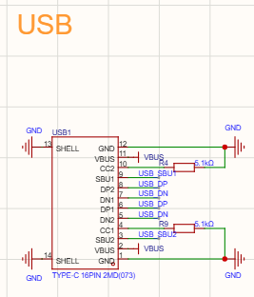
This schematic section details the USB Type-C (16-pin) connector interface. It serves as the primary gateway for firmware deployment, serial debugging, and 5V system power input. By utilizing the native USB capabilities of the ESP32-S3, this interface allows the robot to be programmed and powered through a single, industry-standard cable.
2. Design Rationale
- Universal Compatibility (CC Logic): The inclusion of two 5.1kΩ pull-down resistors (R4, R9) on the CC1 and CC2 pins is a critical design choice. These resistors signal to a USB-C Power Delivery (PD) source or an E-marked cable that the robot is a "Sink" device (power consumer), ensuring that the upstream source provides the necessary 5V on the VBUS line.
- Signal Integrity: The differential data pairs (USB_DP and USB_DN) are mapped to pins 5 through 8. In the subsequent PCB layout phase, these will be routed as a 90Ω differential pair to maintain signal impedance and prevent data corruption during high-speed transfers.
- Reversible Connectivity: The pinout configuration is symmetrical, supporting the reversible nature of the USB-C standard. This enhances user convenience and reduces mechanical wear on the port.
- Mechanical and Electrical Grounding: The SHELL pins (13, 14) are tied directly to GND. This provides structural stability to the connector and creates a low-impedance path for Electrostatic Discharge (ESD), protecting the sensitive internal SoC from potential high-voltage transients during plug-in events.
3. Expected Outcome
The implementation of this USB-C interface ensures seamless integration with modern development environments. It provides a reliable 12Mbps (Full Speed) data link to the ESP32-S3's internal USB-Serial/JTAG controller, enabling real-time monitoring of the robot's "brain" without the need for external bridge chips. Furthermore, the standardized power negotiation ensures the robot can be safely powered by a wide variety of USB chargers and laptop ports.

Power Regulation and Low-Noise Supply Network
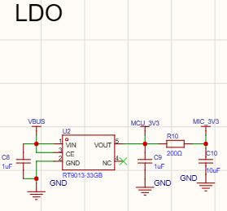
1. Functional Overview
This schematic section highlights the Low-Dropout (LDO) Regulator circuit, which is responsible for stepping down the 5V VBUS (from USB) to a stable 3.3V required by the system's digital and analog components. It utilizes the RT9013-33GB to provide a clean, regulated power rail, with specific filtering tailored for noise-sensitive peripherals like the microphone.
2. Design Rationale
- Regulator Selection: The RT9013 was selected for its high Power Supply Rejection Ratio (PSRR) and low quiescent current. This ensures that high-frequency noise from the USB power source is effectively filtered out before reaching the MCU.
- Input/Output Filtering:
  - C8 (1uF) acts as the input reservoir, stabilizing the 5V line and providing local energy storage for the regulator.
  - C9 (1uF) provides primary output stability for the MCU_3V3 rail, ensuring the ESP32-S3 receives a steady voltage during varying logic states.
- Analog Noise Isolation (RC Filter):
  - A critical design feature is the RC Low-Pass Filter composed of R10 (200Ω) and C10 (10uF).
  - This secondary stage creates the MIC_3V3 rail. By isolating the microphone's power supply from the main digital rail, we prevent high-frequency digital switching noise from the MCU from coupling into the sensitive audio pre-amplifier stage.
- Enable Logic: The CE (Chip Enable) pin is tied directly to VIN, ensuring the 3.3V rail is active as soon as USB power is applied, which is standard for this bus-powered application.
3. Expected Outcome
This power architecture provides a dual-benefit: a stable voltage source for the main controller and a highly filtered, "clean" rail for the audio sensors. By implementing the RC filter for the microphone supply, the design significantly reduces the noise floor of the recorded audio, which is essential for the reliability of the downstream Cloud AI voice recognition and ASR tasks. The overall thermal performance remains excellent due to the efficient selection of the LDO for the intended current draw.

Audio Power Amplifier and Differential Filtering
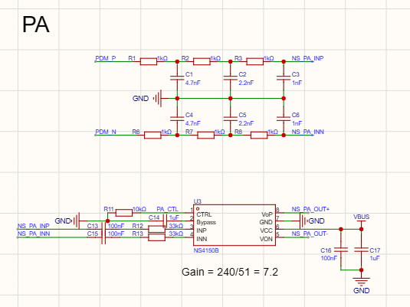

1. Functional Overview
This schematic section represents the robot's Audio Power Amplifier (PA) subsystem. It is designed to convert high-frequency Pulse Density Modulation (PDM) digital signals from the ESP32-S3 into audible analog signals to drive the speaker. The circuit features a multi-stage passive filter followed by an NS4150B differential amplifier, ensuring high-fidelity audio playback for the robot’s voice and interaction sounds.
2. Design Rationale
- 3rd-Order Passive Low-Pass Filter:
  - The top network (R1-R3, C1-C3 for the positive rail and R6-R8, C4-C6 for the negative) forms a differential 3rd-order RC low-pass filter.
  - This is essential for PDM signals, as it aggressively suppresses the high-frequency quantization noise (carrier frequency) and recovers the baseband analog audio envelope. A 3rd-order slope provides a much sharper cutoff than simpler filters, resulting in a cleaner signal for the amplifier.
- Amplifier Configuration (NS4150B):
  - The NS4150B is a high-efficiency Class-D amplifier chosen for its low EMI and differential input/output capabilities, which are ideal for the noisy environment of a mobile robot.
  - Gain Setting: The gain is calculated as $Gain = 240 / 51 = 7.2$, a value chosen to maximize volume without clipping, based on the speaker's impedance and the PDM signal's voltage swing.
- Pop Noise Suppression (PA_CTL):
  - A 10kΩ pull-down resistor (R11) is connected to the CTRL (Pin 1). This ensures the PA remains in a low-power shutdown mode during the MCU's boot-up phase, preventing the "pop" sounds often caused by transient GPIO states.
- AC Coupling and Bias:
  - C13 and C15 (100nF) are used as AC coupling capacitors to block any DC offset from the filter stage.
  - C14 (1uF) on the Bypass (Pin 2) provides a stable internal reference voltage, which is critical for reducing Total Harmonic Distortion (THD).
- Power Filtering: C16 (100nF) and C17 (1uF) are placed immediately adjacent to the VCC (Pin 6) to handle high-frequency transients and provide bulk decoupling, ensuring the amplifier remains stable during high-output peaks.
3. Expected Outcome
The implementation of this differential audio path results in a robust audio system that is highly resistant to common-mode interference from the robot's motors and Wi-Fi radio. The 3rd-order filtering ensures a smooth, natural sound quality suitable for human-robot interaction, while the hardware-level shutdown control (PA_CTL) ensures a professional user experience by eliminating unwanted noise during power-on cycles.

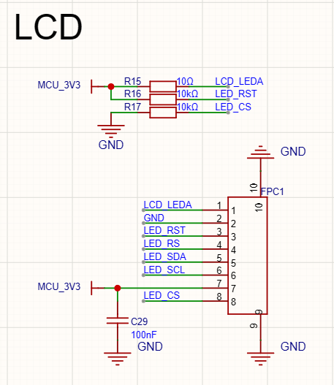
LCD Interface and Visual Feedback System
1. Functional Overview
This schematic section defines the interface for the ST7789 LCD, which serves as the robot's primary visual output for displaying facial expressions and system status. The connection is established via a 10-pin FPC (Flexible Printed Circuit) connector, utilizing a high-speed serial interface to ensure smooth animation and low-latency interaction.
2. Design Rationale
- Interface Selection: The display uses a 4-wire serial interface (SDA, SCL, RS/DC, CS). This configuration was chosen to minimize the number of GPIO pins required on the ESP32-S3 while maintaining a high enough refresh rate for fluid "desk fatigue" combat animations.
- Backlight Current Limiting:
  - R15 (10Ω) is a crucial current-limiting resistor for the LCD_LEDA (Anode) pin.
  - It ensures the backlight LEDs operate within their safe current range, preventing thermal degradation and extending the lifespan of the display panel.
- Control Logic & Stability:
  - R16 (10kΩ) acts as a pull-up for the LED_RST (Reset) line, ensuring the display remains in a stable state and does not inadvertently reset due to floating signal noise.
  - R17 (10kΩ) is used as a pull-down for LED_CS (Chip Select) to keep the peripheral deselected by default, preventing bus contention during the MCU's boot-up phase.
- Power Decoupling: C29 (100nF) is placed immediately adjacent to the MCU_3V3 input of the FPC connector. This filters out high-frequency switching noise from the digital data lines, ensuring a clean power supply for the display's internal driver IC.
3. Expected Outcome
The integration of this LCD module allows the robot to convey "emotions" through various facial expressions, a core requirement for its role in reducing user fatigue. The hardware-level current limiting and pull-up/down resistors ensure that the display is both electrically robust and reliable over long periods of operation. By utilizing a compact FPC connector, the design maintains a small physical footprint, fitting perfectly within the robot's "face board" architecture.
.

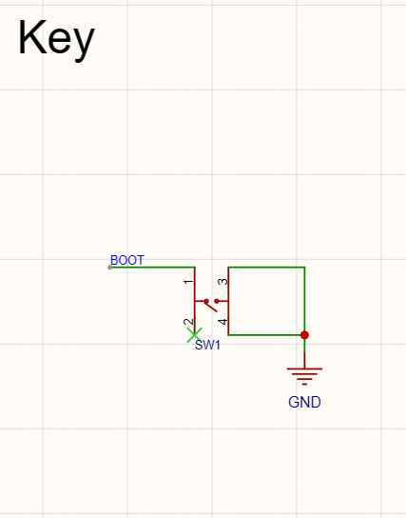
Manual Input and Boot Control Interface
1. Functional Overview
This schematic section highlights the Manual Tactile Switch (SW1), which is configured as the BOOT button for the robot. Its primary role is to provide a physical interface for the user to interact with the ESP32-S3's boot sequence, enabling manual firmware flashing or triggering user-defined software interruptions during the robot's operation.
2. Design Rationale
- Active-Low Logic: The switch is designed in an active-low configuration. One side is tied to the BOOT (IO0) signal of the ESP32-S3, while the other side is connected directly to GND. When the button is pressed, it pulls the IO0 pin to a logic-low level.
- Bootstrap Functionality: Per the ESP32-S3 hardware specifications, holding the BOOT pin low during power-up or reset forces the SoC into Serial Bootloader Mode. This hardware-level entry point is essential for initial firmware deployment and recovery if the application code becomes corrupted.
- GPIO Reusability: Beyond its role during the boot sequence, this switch is mapped to IO0, allowing it to be used as a general-purpose functional button (e.g., "Mode Switch" or "Emergency Stop") once the robot has successfully booted into its main application.
- Mechanical Integrity: The use of a standard 4-pin tactile switch footprint provides superior mechanical stability on the PCB compared to 2-pin variants, ensuring the component can withstand repeated manual presses during the development and testing phases.
3. Expected Outcome
The inclusion of this manual switch ensures that the robot is always accessible for programming, even when wireless (OTA) updates are not feasible. It provides a reliable fail-safe for the developer and adds a layer of manual control for the end-user. By grounding the signal directly upon activation, the design guarantees a clean logic transition, enabling the ESP32-S3 to accurately detect user input for state changes or bootloader entry.

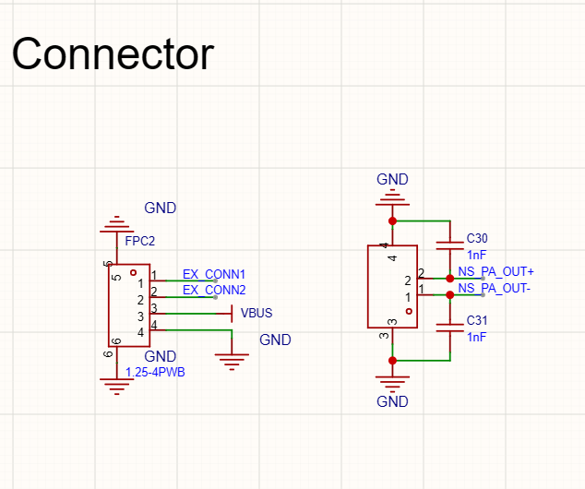
Peripheral Connectors and Signal Interfacing
1. Functional Overview
This schematic section details the External Connector (FPC2) and the Speaker Output Terminal. These components serve as the physical interface between the main PCB and external hardware modules. The design facilitates power distribution and high-fidelity audio transmission while maintaining modularity in the robot's hardware architecture.
2. Design Rationale
- Expansion Port (FPC2/1.25-4PWB):
  - This 4-pin connector provides access to VBUS (5V) and GND, along with two general-purpose signal lines (EX_CONN1, EX_CONN2).
  - The choice of a 1.25mm pitch connector (or FPC equivalent) balances spatial efficiency with the mechanical robustness required for connecting sub-boards, such as the robot's "body board" or specialized sensor arrays.
- Speaker Output & EMI Filtering:
  - The output terminal carries the amplified differential audio signals (NS_PA_OUT+ and NS_PA_OUT-) directly from the NS4150B power amplifier.
  - C30 and C31 (1nF) are implemented as EMI suppression capacitors. By shunting high-frequency switching noise from the Class-D amplifier to GND, these capacitors prevent the speaker wires from acting as antennas, thereby reducing electromagnetic interference (EMI) that could affect the sensitive I2S microphone or Wi-Fi signals.
- Common Grounding: Both connectors share a unified GND plane to ensure a stable reference voltage and minimize ground loops between interconnected modules.
3. Expected Outcome
This interfacing strategy ensures the robot remains modular and easy to assemble. The inclusion of dedicated filtering on the audio output ensures high-quality sound reproduction without compromising the integrity of other high-speed digital signals on the board. By providing a standardized expansion port, the design allows for future hardware upgrades or additional sensor integration with minimal redesign.

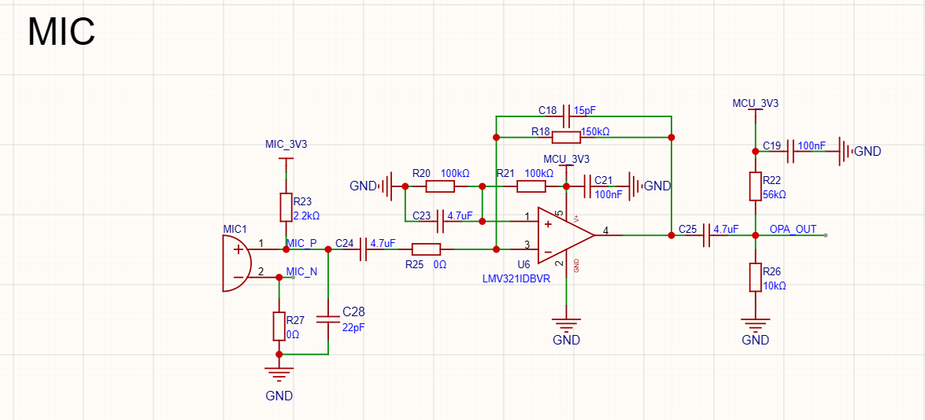

Microphone Preamplifier and Analog Signal Conditioning
1. Functional Overview
This schematic section details the Analog Microphone Preamplifier circuit. Its primary role is to capture low-amplitude acoustic signals from the electret microphone (MIC1) and amplify them to a level suitable for the ESP32-S3's Analog-to-Digital Converter (ADC). This module is essential for the robot's voice interaction capabilities, providing the raw audio data needed for ASR (Automatic Speech Recognition) and Cloud AI processing.
2. Design Rationale
- Microphone Biasing:
  - R23 (2.2kΩ) provides the necessary DC bias current from the filtered MIC_3V3 rail to the electret microphone.
  - Using the dedicated MIC_3V3 supply (which, as noted in the LDO section, is isolated via an RC filter) is critical here to prevent digital switching noise from appearing as audible hiss in the recordings.
- Non-Inverting Amplification (LMV321):
  - The LMV321IDBVR is a rail-to-rail operational amplifier chosen for its low power consumption and small footprint.
  - Gain Calculation: The gain is determined by the feedback network. With R18 (150kΩ) and R21 (100kΩ) in a non-inverting configuration, the gain is approximately $1 + (150/100) = 2.5$.
  - C18 (15pF) in parallel with the feedback resistor acts as a high-frequency pole to prevent oscillations and filter out electromagnetic interference (EMI).
- DC Offsetting and Biasing:
  - Since the ESP32-S3 ADC can only measure positive voltages, the audio signal must be "lifted" to a mid-rail reference.
  - R20 and R21 (100kΩ each) form a voltage divider that sets the common-mode voltage to 1.65V ($VCC/2$).
  - C23 (4.7uF) provides a low-impedance AC ground for this bias point, ensuring the reference remains stable during signal swings.
- AC Coupling:
  - C24 (4.7uF) and C25 (4.7uF) are used as input and output coupling capacitors, respectively. They block DC offsets while allowing the AC audio signal to pass through the amplification stages.
- Output Protection and Filtering:
  - R22 and R26 form a final voltage divider/protection stage at OPA_OUT to ensure the signal remains within the safe input range of the MCU's ADC pins.
  - C19 (100nF) provides final high-frequency decoupling for the amplifier's power supply pin.
3. Expected Outcome
The resulting preamplifier circuit delivers a centered, high-fidelity analog signal with minimal noise floor. By leveraging the isolated power rail and carefully calculated gain, the system can reliably capture human speech even in environments with moderate ambient noise. This hardware-level conditioning significantly improves the accuracy of the robot's subsequent digital signal processing and AI-driven voice responses.

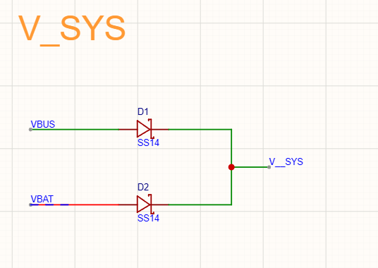
Power Path Management and Voltage ORing
1. Functional Overview
This schematic section illustrates the Power Path Management circuit, which utilizes a dual-diode ORing configuration to create the main system power rail, V_SYS. It allows the robot to seamlessly switch between two power sources—VBUS (USB 5V) and VBAT (Battery)—ensuring that the system remains powered as long as at least one source is available.
2. Design Rationale
- Schottky Diode Selection (SS14):
  - Two SS14 Schottky diodes (D1 and D2) are used for their low forward voltage drop ($V_f$) and fast switching speeds.
  - In a battery-powered robotics application, minimizing the voltage drop across the diodes is critical to maximize energy efficiency and ensure sufficient headroom for the downstream 3.3V LDO regulator.
- Reverse Current Protection:
  - The diodes act as one-way valves. This prevents VBUS from inadvertently charging the battery in an uncontrolled manner (which could be hazardous) and prevents the battery from back-powering the USB port of a connected computer.
- Automatic Source Prioritization:
  - The circuit naturally implements a "highest voltage wins" logic. If both USB and a fully charged battery are connected, the source with the higher potential will supply the load, effectively reducing the drain on the battery when a tethered power source is available.
- Simplicity and Reliability:
  - This passive ORing approach was chosen over complex Power Path ICs to reduce the Bill of Materials (BOM) count and PCB complexity while providing a robust, fail-safe mechanism for the robot's basic power needs.
3. Expected Outcome
This design ensures the robot's "brain" and peripherals have a continuous power supply during transitions, such as unplugging the USB cable to let the robot move autonomously. The use of SS14 diodes provides a balance between cost-effectiveness and electrical performance, protecting the delicate internal electronics from reverse-polarity damage and source contention.

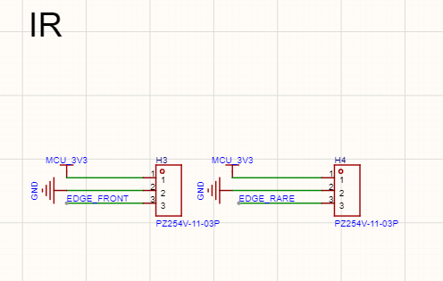
Infrared (IR) Sensor Interface for Edge Detection
1. Functional Overview
This schematic section defines the interface for the robot's Infrared (IR) sensors via two 3-pin connectors (H3 and H4). These sensors are strategically positioned to serve as an edge detection system (cliff sensors), providing critical environmental feedback to the ESP32-S3 main controller to prevent the robot from falling off surfaces such as desks or tables.
2. Design Rationale
- Sensor Selection (TCRT5000):
  - The design utilizes TCRT5000 IR reflective sensors.
  - These were selected to replace the initial Time-of-Flight (ToF) sensor concept to provide a more cost-effective and reliable solution for short-range surface detection.
- Interface Configuration:
  - Each connector utilizes a standard 3-pin layout: Pin 1 (MCU_3V3) for power, Pin 2 (GND) for the common ground, and Pin 3 for the signal return (EDGE_FRONT and EDGE_RARE).
  - This standardized wiring allows for easy maintenance and ensures that the sensors can be mounted on the "body board" while communicating directly with the main controller.
- Signal Mapping:
  - The EDGE_FRONT and EDGE_RARE signals are routed to the ESP32-S3's GPIOs (IO17 and IO18).
  - This enables the firmware to monitor the surface status in real-time at both the leading and trailing edges of the robot's chassis.
- Power Stability:
  - The sensors are powered by the MCU_3V3 rail.
  - As established in the LDO design section, this rail is heavily decoupled to ensure that the IR emitters and receivers do not introduce switching noise into the more sensitive analog components, such as the microphone preamplifier.
3. Expected Outcome
The implementation of these IR interfaces creates a robust "Safety Priority Layer" for the robot's motion control. By detecting the absence of a reflective surface (indicating a desk edge), the ESP32-S3 can execute an immediate "stop and reverse" command, bypassing other UI or manual controls to ensure the physical integrity of the hardware. This hardware-level safety feature is fundamental for a desktop robot designed to operate autonomously in potentially hazardous table-top environments.

